This is my Submission for SEAC xxxiii (Paper Title Style)
Loukas Zacheilas (Author style + SmallCaps for Surname)
University of Thessaly (Affiliation style)
Themis G. Dallas (Author style + SmallCaps for Surname)
University of Thessaly (Affiliation style)
Submission type
Oral / Poster (Normal style)
Keywords
Keyword one, Keyword two, Keyword three (Normal style)
Abstract
(Normal style) The abstract should be extended, clearly explaining the background and methodology of the research and —if there are ready— the data, results, and conclusions or its aim and expectations. The length of the text should be approximately 500 to 700 words. Maximum length is three pages, including one image and three to five bibliography references. Add a short biographical info (up to 100 words) and your orcid.
(Normal style) If you need to add a table, please use the following template. Start with Table caption & Table cell styles and modify alignments as needed. Do not over-design the table, as we will change all of them to a similar look during typesetting.
Azimuth, horizon height and declination calculations for the Temple of Isis at Stobi. (Table caption style)
 | a (°) |  | h (°) |  | δ (°)
Peristyle | 41 | ±1 | 2 | ±½ | 36 | ±¾
Temple | 47½ | ±½ | 2 | ±½ | 31½ | ±½
Main Altar | 50¼ | ±¼ | 1¾ | ±½ | 29¾ | ±½
Hypogeum | 228¾ | ±¼ | 2¼ | ±½ | −27¾ | ±½
South Hole | 139 | ±3 | 40¼ | −21 / +14 | 0 | −19 / +13
North Hole | 320½ | ±3 | 30 | −17 / +22 | 56¼ | −12 / +6

(Normal style) To place a photograph add a paragraph of Figure style that only holds the photo and follow it with a paragraph of Figure Caption style for the caption. Photographs must be JPG or PNG at 300dpi with maximum width of 16cm. If you have drawings and graphs, increase the resolution to 600dpi and make sure the lines do not look jugged due to compression.
(Normal style) Deadline for abstracts is 21 March 2026. All accepted abstracts will be published in an abstract booklet. File format must be Microsoft Word (preferably .docx).
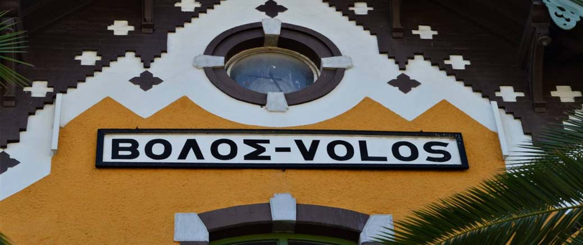
The sign of the train startion in Volos (Figure caption style).
(Normal style) The bibliography should follow the APA style. Examples of its use can be found at: https://apastyle.apa.org/style-grammar-guidelines/references/examples You may also use the citations & bibliography tool of Microsoft Word. Please turn all surnames of authors in the text to Small Caps. In Microsoft Word the shortcut is Shift+Ctrl+K
Bibliography
Rybaczewska, M., & Sparks, L. (2022). Ageing consumers and e-commerce activities. Ageing and Society, 42(8), 1879-1898. https://doi.org/10.1017/S0144686X20001932
Sapolsky, R. M. (2017). Behave: The biology of humans at our best and worst. Penguin Books.
Dillard, J. P. (2020). Currents in the study of persuasion. In M. B. Oliver, A. A. Raney, & J. Bryant (eds.), Media effects: Advances in theory and research (4th ed., 115-129). Routledge.
Biographical note
(Normal style) Loukas Zacheilas 0000-0001-7021-2955 is a professor in the department of Echonomics of the Univeristy of Thessaly. He is also a member of IAU and very active in astronomy outreach, being president of the Society of Astronomy and Space in Volos.
(Normal style) Themis G. Dallas 0000-0003-0291-5100 is a lab teacher in the department of History, Archaeology and Social Anthropology of the University of Thessaly. His main research interest lies into archaeoastronomy of late antiquity, especially the orientation of early Christian churches.
Corresponding author
Themis Dallas tgd@uth.gr

